# Chapter Summaries

## CHAPTER 1

Chapter Summary: Chemical Reactions and Equations

1. Fundamental Principles and Representation   
Chemical reactions involve the transformation of reactants into products, characterized by changes such as gas evolution, temperature shifts, color variation, or precipitate formation. Governed by the law of conservation of mass, the total mass of reactants equals that of products. These reactions are systematically represented through chemical equations, which use symbols and formulae (e.g., Mg + O₂ → MgO) to denote substances and their states—solid (s), liquid (l), gas (g), or aqueous (aq). Unbalanced skeletal equations are refined via stoichiometric coefficients to ensure atomic equivalence on both sides. For instance, the skeletal equation Fe + H₂O → Fe₃O₄ + H₂ becomes balanced as 3Fe(s) + 4H₂O(g) → Fe₃O₄(s) + 4H₂(g), preserving mass conservation.

2. Classification of Reaction Types   
Chemical reactions are categorized by their mechanisms and energy dynamics. *Combination reactions* merge reactants into a single product, such as 2H₂(g) + O₂(g) → 2H₂O(l). Conversely, *decomposition reactions* split compounds into simpler substances via energy input: thermal (CaCO₃ → CaO + CO₂), electrolytic (2H₂O → 2H₂ + O₂), or photolytic (2AgCl → 2Ag + Cl₂). *Displacement reactions* involve element substitution, where a more reactive species replaces a less reactive one (e.g., Fe + CuSO₄ → FeSO₄ + Cu). In *double displacement reactions*, ions exchange between compounds, often forming precipitates like BaSO₄ in BaCl₂ + Na₂SO₄ → BaSO₄↓ + 2NaCl. Energy changes further classify reactions: *exothermic* processes release heat (e.g., combustion), while *endothermic* ones absorb energy (e.g., photosynthesis).

3. Redox Reactions and Practical Applications   
Oxidation-reduction (redox) reactions underpin numerous chemical processes. Oxidation involves oxygen gain or hydrogen loss, while reduction entails oxygen loss or hydrogen gain. In ZnO + C → Zn + CO, carbon is oxidized, and zinc oxide is reduced. These principles manifest in daily life and industry: iron rusting (4Fe + 3O₂ + xH₂O → 2Fe₂O₃·xH₂O), fat rancidity due to oxidation, and methanol synthesis (CO + 2H₂ → CH₃OH). Redox also drives metal extraction, such as copper displacement from AgNO₃ (Cu + 2AgNO₃ → Cu(NO₃)₂ + 2Ag). Mitigation strategies, like nitrogen flushing to prevent rancidity or protective coatings to inhibit corrosion, highlight the practical management of chemical reactions.

4. Energy Dynamics and Experimental Observations   
Energy changes in reactions are experimentally observable. Dissolving ammonium nitrate (NH₄NO₃) in water cools the solution (endothermic), whereas hydrating anhydrous CuSO₄ or reacting iron with CuSO₄ releases heat (exothermic). Such experiments underscore the link between molecular interactions and thermal effects. Similarly, decomposition reactions require external energy, distinguishing them from spontaneous processes like combustion.

5. Interconnected Concepts and Real-World Relevance   
The interplay of reaction types and energy dynamics is evident in natural and industrial contexts. Respiration (C₆H₁₂O₆ + 6O₂ → 6CO₂ + 6H₂O + energy) exemplifies exothermic catabolism, while electrolysis of water demonstrates energy storage via endothermic splitting. Precipitation reactions purify substances, as in barium sulfate formation, and redox principles guide metallurgy and pollution control. Understanding these connections fosters innovation in material science and environmental sustainability, illustrating chemistry’s central role in addressing global challenges.

This synthesis of principles, classifications, and applications provides a cohesive framework for analyzing chemical reactions, emphasizing their theoretical foundations and practical significance in both academic and real-world contexts.

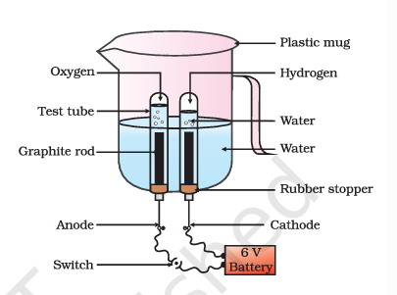

The figure shows a simple electrolysis cell used to produce hydrogen and oxygen gases from water. The cell consists of a plastic mug containing water, a test tube filled with water, a graphite rod, a rubber stopper, and a 6V battery. The graphite rod is connected to the anode, and the cathode is connected to the other end of the battery. When the switch is closed, an electric current flows through the circuit, causing water to decompose into hydrogen and oxygen gases. The hydrogen gas is collected in the test tube, while the oxygen gas is collected in the plastic mug. This experiment is commonly used in chemistry to demonstrate the electrolysis of water and the production of hydrogen and oxygen gases. - The figure shows a setup for a chemical reaction between hydrogen and oxygen gases to produce water. The setup includes a plastic mug, a test tube, a graphite rod, a rubber stopper, and a 6V battery. The hydrogen and oxygen gases are introduced into the test tube, and the reaction is initiated by the battery. The products of the reaction are water, which is collected in the plastic mug.  
This figure is significant because it demonstrates a chemical reaction between two gases to produce a liquid. The reaction is a classic example of electrolysis, where an electric current is used to cause a chemical change. The figure also shows the use of a battery as a source of electrical energy, which is a common method for initiating chemical reactions.  
Overall, this figure provides a visual representation of a chemical reaction and the equipment used to carry it out. It can be used to help students understand the concept of chemical reactions and the role of electricity in causing them.

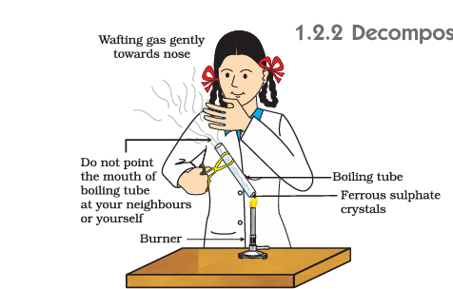

This figure is from a textbook and represents a chemistry experiment demonstrating the decomposition of ferrous sulfate crystals. The figure shows a person wearing a lab coat, holding a boiling tube containing ferrous sulfate crystals. The person is using a burner to heat the boiling tube, causing the crystals to decompose and release a gas. The gas is being wafted gently towards the person's nose, and there is a warning to "do not point the mouth of the boiling tube at your neighbors or yourself." This experiment is likely being used to teach students about chemical reactions and the properties of ferrous sulfate. - The figure in the textbook is an illustration of a chemical reaction, specifically the decomposition of ferrous sulfate crystals. The reaction is represented by the following chemical equation:  
  
\[ \text{Fe}_2\text{SO}_4 \cdot 7\text{H}_2\text{O} \xrightarrow{\text{Heat}} \text{Fe}_2\text{SO}_4 + 7\text{H}_2\text{O} \]  
  
This equation shows that when ferrous sulfate crystals are heated, they decompose into ferrous sulfate and water vapor. The figure shows a student performing the experiment by heating the crystals in a boiling tube over a burner. The student is wafting the gas gently towards their nose to detect the smell of sulfur dioxide, which is a product of the reaction.  
  
The significance of this figure is to demonstrate the concept of a chemical reaction and how it can be represented using a chemical equation. It also shows the practical aspect of performing a chemical reaction and the importance of safety precautions, such as not pointing the mouth of the boiling tube at oneself or others.

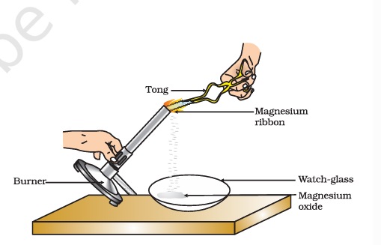

This figure is a diagram from a textbook that illustrates the process of heating magnesium ribbon in a laboratory setting. Here is a detailed description of the figure and its educational context:  
  
1. **Burner**: The burner is a device used to heat the magnesium ribbon. It is typically a Bunsen burner or a similar type of gas burner.  
  
2. **Tong**: The tong is a tool used to hold and manipulate the magnesium ribbon. It is important to use tongs to handle the hot magnesium ribbon safely.  
  
3. **Magnesium Ribbon**: The magnesium ribbon is a thin strip of magnesium metal. It is being heated by the burner.  
  
4. **Watch-glass**: The watch-glass is a small, flat glass dish used to collect the products of the reaction. In this case, it is collecting magnesium oxide.  
  
5. **Magnesium Oxide**: The white powdery substance that collects in the watch-glass is magnesium oxide (MgO). This is the product of the reaction between magnesium and oxygen.  
  
The figure represents the chemical reaction between magnesium and oxygen, which results in the formation of magnesium oxide. This reaction is typically used to demonstrate the properties of magnesium and the concept of oxidation. The educational context of this figure is to teach students about chemical reactions, the properties of metals, and the concept of oxidation. It also serves as a practical demonstration of how to conduct a simple chemical reaction in a laboratory setting. - The figure shows a chemical reaction between magnesium ribbon and oxygen gas, resulting in the formation of magnesium oxide. The significance of this figure is to demonstrate a chemical reaction and to show how chemical equations can be written to represent the reaction. The reaction is represented by the following chemical equation:  
  
\[ \text{Mg} + \text{O}_2 \rightarrow \text{MgO} \]  
  
This equation shows that magnesium (Mg) reacts with oxygen (O₂) to form magnesium oxide (MgO). The figure also shows the use of a burner to heat the magnesium ribbon, which is then used to ignite the reaction. The reaction is exothermic, releasing heat and light. The figure is an example of a chemical reaction and is used to illustrate the concept of chemical equations.